**Project 2. No Show Appointments**

Medical appointments are the services that helps patients to book their appointments with the doctors for their health check. However, not all patients show up for their appointment as their bookings.

The project is about the investigation of the factors that affecting the medical appointmenst in Brasil.

There are many factors that involve in the appointments postpones. Here, the project is focusing on questions as below:

1. What is the ages in patients involving in the appointments?
2. Is there any difference in the gender affecting the appointment show up?
3. What is the difference in percentage between the patients joining the wellfare program and the patients that not joining the wellfare program for their appointment show up?

**1.Data wrangling**

Data is store in csv file with the name ‘KaggleV2-May-2016.csv’.First, we need to load the file into the Jupyter Notebook for the analysis.

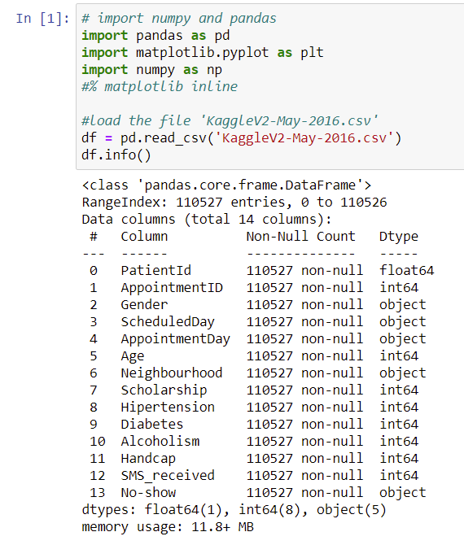

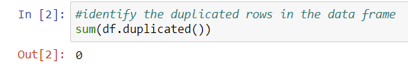

There is 110,527 rows and 14 columns in the dataset. There is no null values and duplicates in the dataset. However, there is 1 age group that has the value of -1 that we need to remove it from the dataset as following:

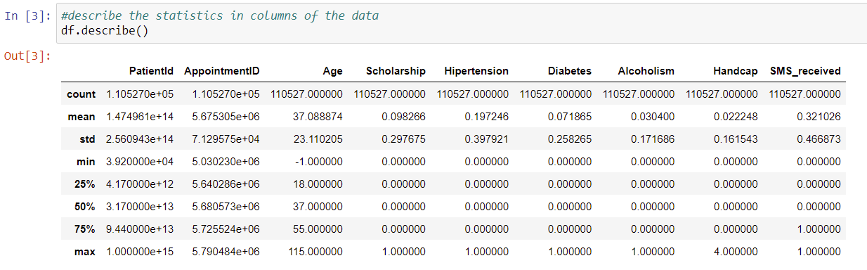

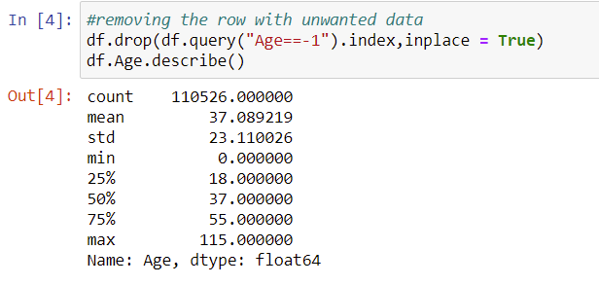

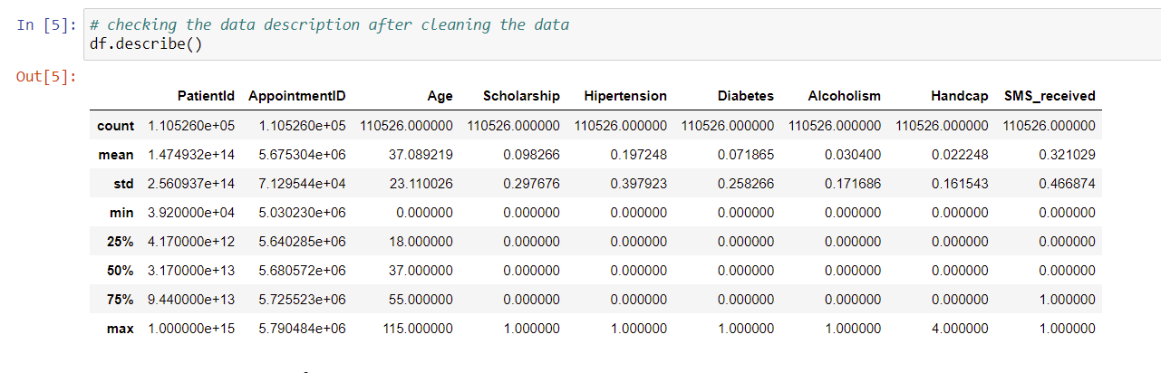

The dataset is now cleaned with 110,526 rows and 14 columns.

**2. Analysis**

**2.1 Identify the group age.**

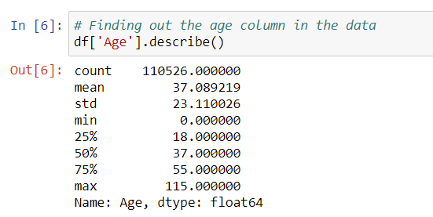

- The average age of the sample was 37 years old, in which the minimum age is 0 (less than 1 years old) and the highest was 115 years old.

- 50% of the samples aged from 0 to 37 years old.

- 75% of the samples age from 0 to 55 years old.

**2.2 Identify the gender**

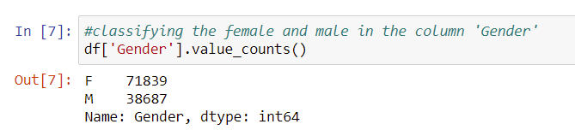

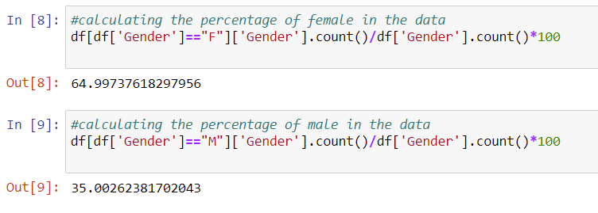

The female number was 71,839 which represent 65% the sample.

The male number was 38,687 which represent 35% the sample.

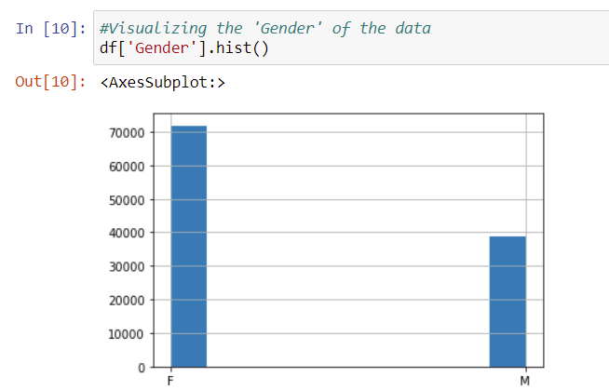

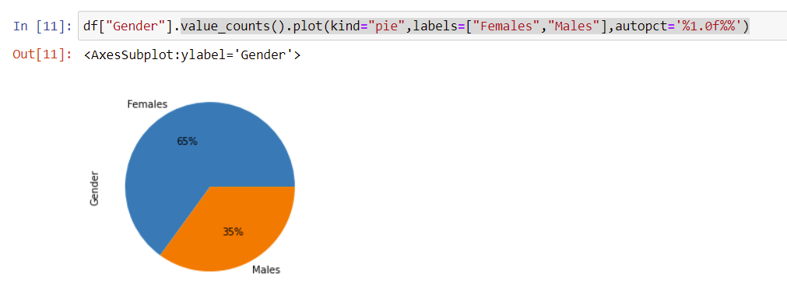

**2.3 Finding the relationship between the gender and the No-show results**

**2.3.1 Male number that not showing at the appointment**

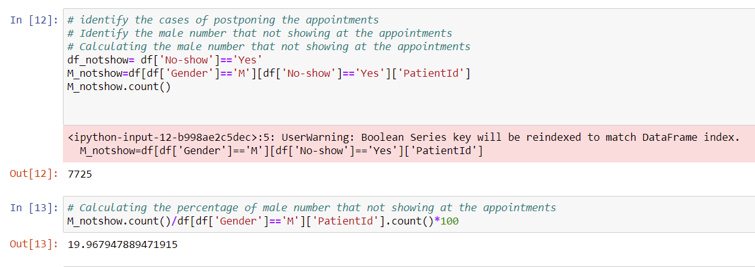

There was 7,725 male out of 38,687 that not appearing in the appointments. The percentage was 19.97%

**2.3.2 Female number that not showing at the appointment**

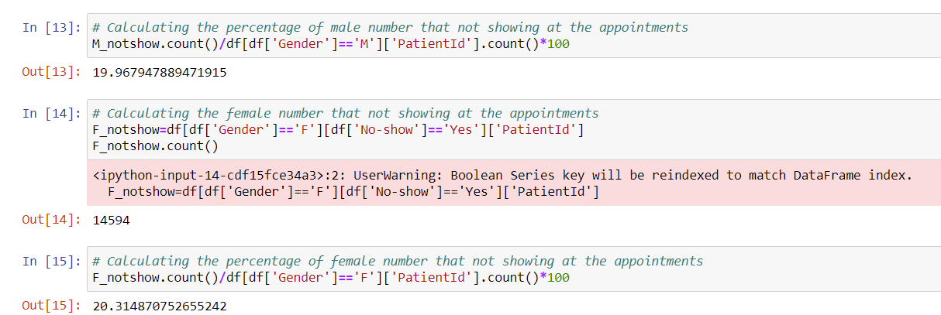

There was 14,594 female out of 71,839 that not appearing in the appointments. The percentage was 20.3%

**Conclusion:** a little bit higher of male rate that not showing at the appointments compared with the female. Therefore, Gender is not the factor that affecting the results of the appoinments.

**2.3 Identify people involving the Brasilian wellfare**

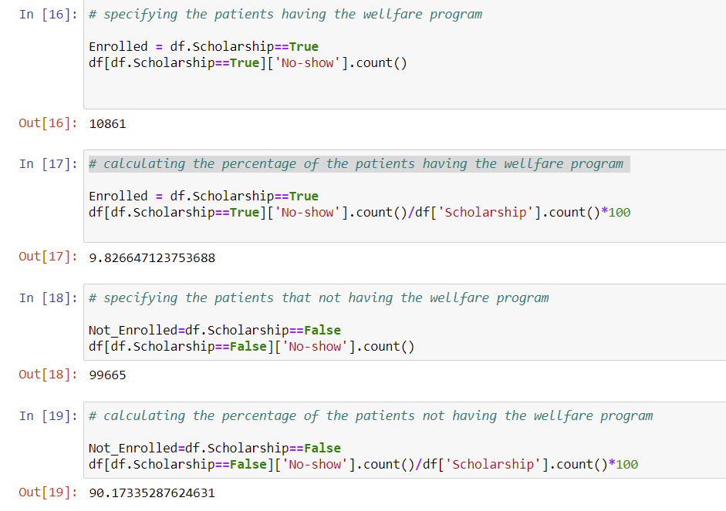

There are 10,861 (9.8%) people joining in the Brasilian and 99,665 (90%) not joining the program.

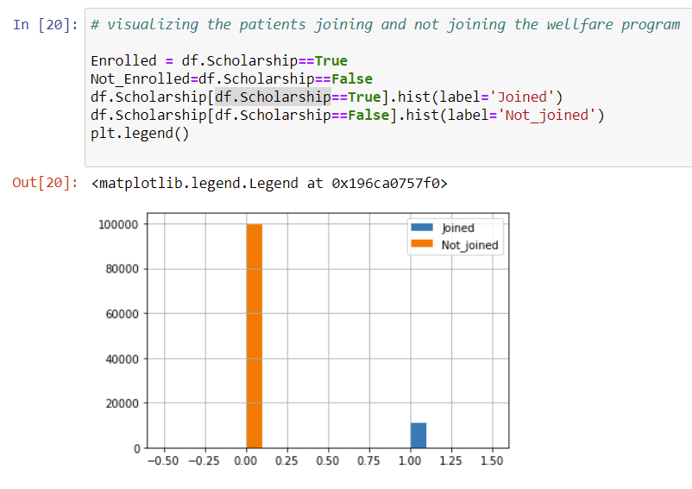

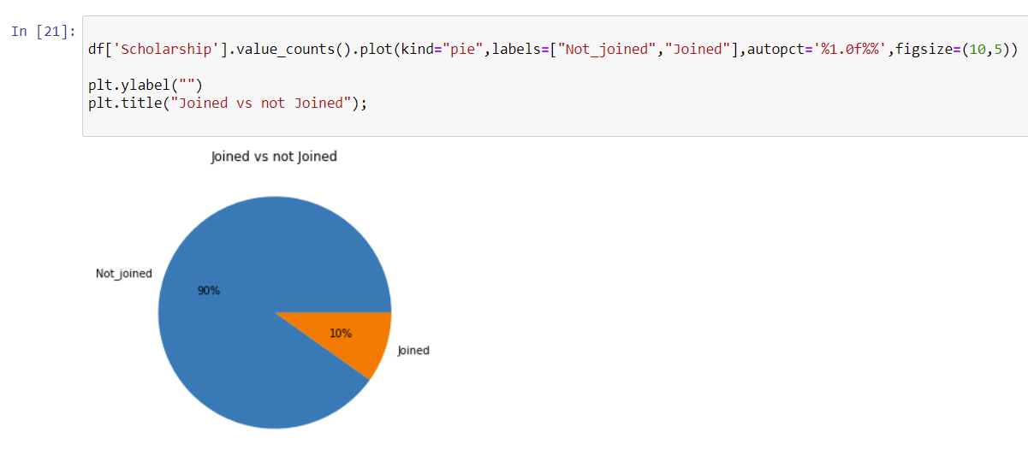

**2.4 Relationship between the wellfare program with the No-show results**

**2.4.1 Number of people joining the wellfare program that didn’t show up at the appointments**

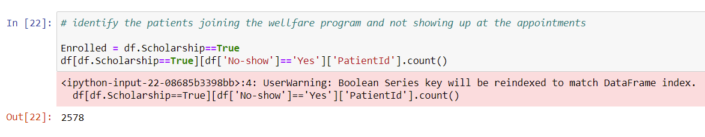

2.4.2 **The percentage of people joining the wellfare program that didn’t show up at the appointments**

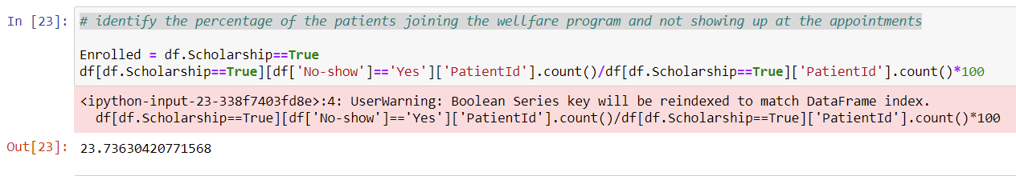

There are 2,578 people **joining the program** didn’t show up at the appointmes. The percentage was 23.74%

**2.4.3 Number of people not joining the wellfare program that didn’t show up at the appointments**

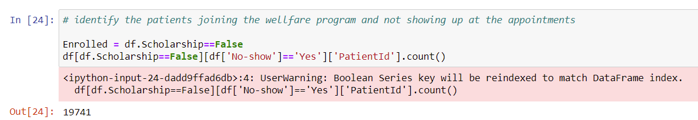

**2.4.4 The percentage of people not joining the wellfare program that didn’t show up at the appointments**

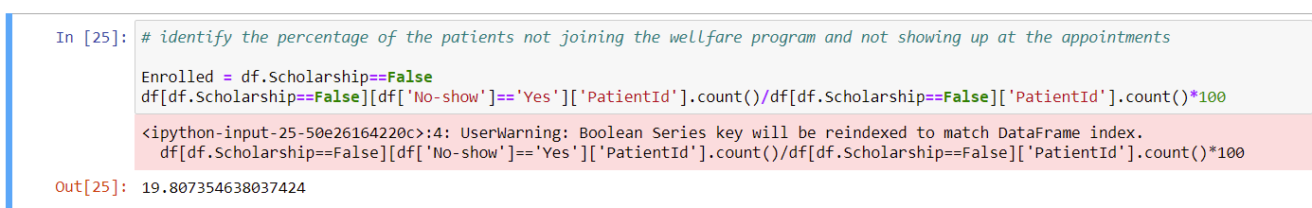

There are 19,741 out of 99,665 not joining the program didn’t show up at the appointmes. The percentage was 19.8 %

**Conclusion**

- The average age of the sample was 37 years old, in which the minimum age is 0 (less than 1 years old) and the highest was 115 years old, 50% of the samples aged from 0 to 37 years old and 75% from 0 to 55 years old.

- There is no difference in between female and male patients in showing up for their appointments.

- The percentage of patients having the wellfare program that didn’t show up for their appointments(23.74%) is higher compared with the patients who don’t have the wellfare program (19.8%)